Ministry of Health Threat & hazard identification and risk assessment (Thira) guide

The Threat & Hazard Identification and Risk Assessment (THIRA) process helps Ministries of Health identify capabilities and resource requirements necessary to address anticipated and unanticipated risks.
  - November 2013

Overview

Every community should understand the risks it faces. By understanding its risks, planners can make smart decisions about how to manage risk, including developing needed capabilities. Risk is the potential for an unwanted outcome resulting from an incident, event, or occurrence, as determined by its likelihood and the associated consequences. By considering changes to these elements, a community can understand how to best manage and plan for its greatest risks across the full range of the threats and hazards it faces. The Threat & Hazard Identification and Risk Assessment (THIRA) process helps communities identify capability targets and resource requirements necessary to address anticipated and unanticipated risks.

THIRA Process

This Guide describes a four-step process for developing a THIRA:

1. Identify the Threats and Hazards of Concern. Based on a combination of experience, forecasting, subject matter expertise, and other available resources, identify a list of the threats and hazards of primary concern to the community.

2. Give the Threats and Hazards Context. Describe the threats and hazards of concern, showing how they may affect the community.

3. Establish Capability Targets. Assess each threat and hazard in context to develop a specific capability target. The capability target defines success for the capability.

4. Apply the Results. Estimate the resources required to achieve the capability targets through the use of community assets and mutual aid, while also considering preparedness activities, including mitigation opportunities.

The THIRA process is flexible and scalable and will work for communities of all sizes. Communities can adapt these four steps to meet their specific needs and resources.

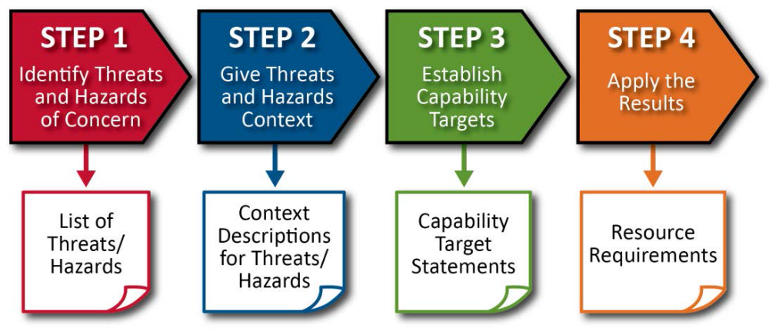

The THIRA process helps communities answer the following questions:

. What does the community need to prepare for?
. What resources are required in order to be prepared?
. What actions (e.g., mitigation activities) could be employed to lessen or eliminate the threat or hazard?
. What impacts need to be incorporated into the community’s recovery preparedness planning?

Developing an effective THIRA requires active involvement from the entire community. When developing and updating THIRAs, jurisdictions should ensure their assessment and planning effort includes representatives and perspectives of the entire community. An informed public is the best advocate for building and sustaining required capabilities and creating a secure and resilient community.

For each THIRA update, communities should also review how the threat and hazard landscape has changed. In particular, consider the inclusion of new or emerging threats and hazards, to include future risks (Step 1); updating threat and hazard context descriptions based on demographic factors (Step 2); and revising capability targets based on current capability levels (Step 3). Communities should refine resource requirements (Step 4) based on changes made in previous steps and review how successful preparedness measures, such as protection or mitigation efforts, affect their THIRAs.

Step 1: Identify the Threats and Hazards of Concern

In Step 1 of the THIRA process, communities develop a list of community-specific threats and hazards. This section:

. Defines the types of threats and hazards that communities should consider
. Introduces sources of threat and hazard information
. Describes factors to consider when selecting threats and hazards for inclusion in the
THIRA
. Provides guidance on updating previous THIRA submissions

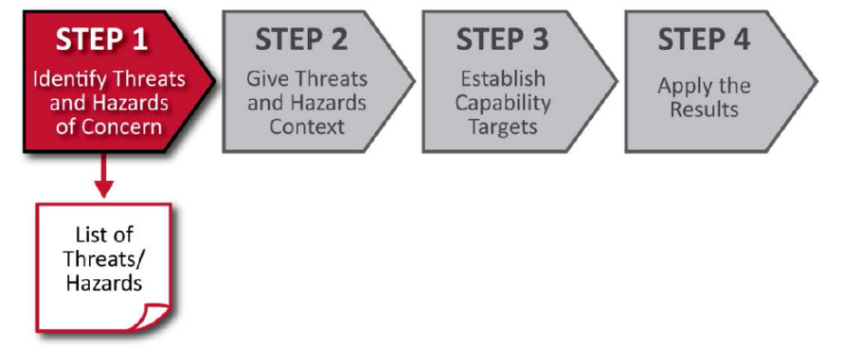

Types of Threats and Hazards

Communities face a variety of threats and hazards. The three types of threats and hazards are:

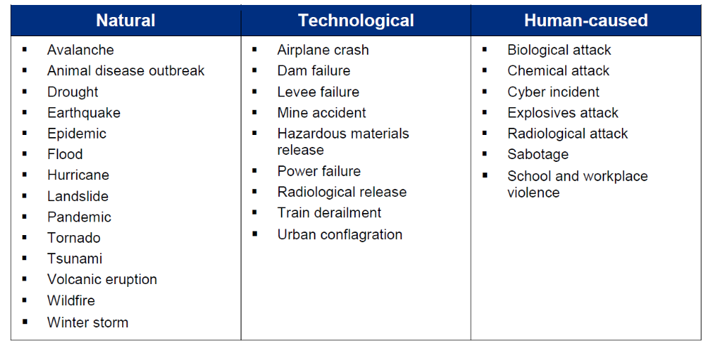

Sources of Threat and Hazard Information

Communities should consult a number of sources to identify threats and hazards during the THIRA process. These sources may include:

. Existing threat and hazard assessments
. Records from previous incidents, including historical data
. Analysis of critical infrastructure interdependencies, including disruptions and failures that may originate elsewhere but produce cascading effects experienced locally (e.g., an electrical power disruption that spreads both geographically and across sectors)
. Intelligence bulletins and assessments
. Community partners, such as:
• Emergency management/homeland security agencies
• Local and state hazard mitigation offices
• Local, Regional, or Federal weather offices
• Provincial/District governments
• Private-sector partners
• Local/national fire, police, emergency medical services, and health departments
• Infrastructure owners and operators
• Ministry officials from Ministries of Defense, Interior, Planning, Municipalities & Public Works, etc.
• Colleges/universities, and other research organizations

Additional Online Sources of Threat and Hazard Information:

. ReliefWeb (http://reliefweb.int)
. Integrated Regional Information Networks (IRIN) (http://www.irinnews.org)
. Global Disaster Alert and Coordination System (http://www.gdacs.org)
. UN Central Emergency Response Fund (http://www.unocha.org/cerf)
. Humanitarian Response Coordinated Assessments (https://assessments.humanitarianresponse.info)
. Inter-Agency Standing Committee (http://www.humanitarianinfo.org/iasc)
. PreventionWeb (http://www.preventionweb.net)
. Humanitarian Early Warning Service (http://www.hewsweb.org/hp)
. International Federation of Red Cross and Red Crescent Societies (http://www.ifrc.org)
. World Health Organization (http://www.who.int)

Factors for Selecting Threats and Hazards

Planners should include only those threats and hazards of significant concern in their THIRA. To identify threats and hazards of significant concern, consider two key factors: likelihood of incident and significance of threat/hazard effects.

Factor #1: Likelihood of Incident

Likelihood is the chance of something happening, whether defined, measured, or estimated objectively or subjectively. Planners should consider only those threats and hazards that could plausibly occur.

As a starting point, communities should consider the threats and hazards that have historically affected them, as well as those threats and hazards that exist regardless of historical occurrence (e.g., earthquakes, industrial accidents, or intelligence-driven assessments of potential terrorist attacks). This should include analyzing after-action reports and information about the root causes of threats and hazards (e.g., major floods caused by inadequate levees), as well as consultation with scientists and appropriate subject matter experts. Planners may also consider looking at historical archives for reports of disasters in the community.

For threats and hazards for which it is difficult to estimate the likelihood of an incident (e.g., terrorism), planners should consider available intelligence data to determine inclusion in the THIRA. Engaging national/local law enforcement or a major urban area intelligence center can provide the necessary insight into these types of events in order to focus on plausible threats. Local public health and medical personnel can also offer insight about health-related concerns such as pandemics.

Planners should take care to not over-rely on historical averages or patterns that may give a false sense of likelihood. For example, many severe natural hazards (such as earthquakes or floods) occur with such low frequency that relying on historical records alone may be misleading. High-magnitude earthquakes, though rare, can have severe consequences and therefore should be considered if the community is at risk for earthquake damage. Planners should also consider the threats and hazards that similar communities include in their planning processes or have recently responded to.

The scale and severity of disasters are growing and will likely pose systemic threats. Increasing changes in demographic trends and technology are making the effects of disasters more complex to manage. Population shifts to vulnerable areas and other demographic changes will affect future disaster management activities and should be considered when selecting threats and hazards.

Factor #2: Significance of Threat/Hazard Effects

The threat/hazard effects represent the overall impacts to the community. Planners should consider only those threats and hazards that would have a significant effect on them. Consider that different incidents present different types of challenges. In some cases the sheer magnitude of the incident may be substantial; others may involve coordination complexities, political sensitivities, or economic and social challenges.

Planners should not limit their THIRA to threats and hazards that they would be able to manage, but should also consider threats and hazards resulting in large-scale disasters or catastrophic incidents. Conversely, planners should exclude from the THIRA threats and hazards with only minor impacts, regardless of likelihood.

Although incidents may have wider regional or national effects, planners should focus strictly on the impacts within their jurisdiction. In some cases, it may be useful to include threats and hazards that occur in other locations if they trigger local effects. For example, an industrial accident at a chemical plant located in one particular community could affect people in another community who are downwind from the accident.

Step 1 Output

The output of Step 1 is a list of the community’s threats and hazards of concern. These threats and hazards will serve as the basis for Step 2.

Step 2: Give the Threats and Hazards Context

In Step 2 of the THIRA, planners add context descriptions to each threat and hazard identified in Step 1. Context descriptions outline the conditions, including time and location, under which a threat or hazard might occur. This section:

. Identifies factors to consider when developing context descriptions
. Provides examples of a completed threat/hazard context description

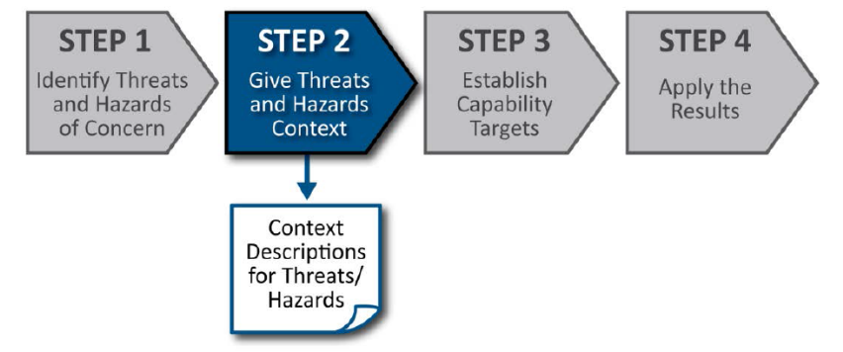
Context Description: Factors to Consider

To develop threat and hazard context descriptions, planners should take into account the time, place, and conditions in which threats or hazards might occur. Planners can use expert judgment or analysis of probability and statistics to inform the descriptions of the different threat and hazard conditions. Consider the following types of questions when developing context for each threat and hazard:

. How would the timing of an incident affect the community’s ability to manage it? What time of day and what season would be most likely or have the greatest impacts?
. How would the location of an incident affect the community’s ability to manage it? Which locations would be most likely or have the greatest impacts: populated areas, coastal zones, industrial or residential areas?
. What other conditions or circumstances make the threat or hazard of particular concern? Atmospheric conditions (e.g., wind speed/direction, relative humidity)? Multiple events occurring at the same time?

Threats and hazards can have different impacts depending on the time, place, and conditions in which they occur. As such, planners may need to develop more than one context description for a threat or hazard. For example, a typhoon-prone community may need multiple context descriptions to account for varying storm intensities, landfall locations, and landfall times.

For any given community, there are countless combinations of threat and hazard conditions that lead to slightly different contexts. Planners need not consider every combination; rather they should include those details that affect what the community needs to be prepared for. For example, a jurisdiction identified a flood as a hazard in Step 1. Planners should consider the time of day and the path of the flood when developing the context statement because the effects and resulting impacts may be different during the day than at night. Effective context descriptions should provide an overall sense of scale for the impacts of a threat or hazard.

Planners should recognize that past experience with threats and hazards may differ from the future threat and hazard environment. Factors such as demographics, climate, and the built environment are subject to change. Planners should consider these factors when developing threat and hazard context descriptions.

Examples of Context Descriptions

Below are two examples of context descriptions for a community. Planners included the following two threats and hazards in its THIRA: an earthquake (natural) and a terrorist attack using an improvised explosive device (human-caused). Each of these threats and hazards includes a context description outlining the conditions, including time and location that are most relevant to the community. These two threats and hazards are for example purposes only; a community may elect to analyze any number of threats and hazards of significant concern.

Threat/Hazard | Earthquake | Terrorism
Context  Description | A magnitude 7.8 earthquake along the Mainland Fault occurring at approximately 2:00 PM on a weekday with ground shaking and damage expected in 19 districts, extending from Alpha District in the south to tau District in the North and into the Zeta Valley. | A potential threat exists from domestic group with a history of using small IEDs in furtherance of hate crimes. There are a number of large festivals planned during the summer at open air venues that focus on various ethnic and religious groups. These events draw on average 10,000 attendees daily.

Step 2 Output

The output of Step 2 is context descriptions for each threat and hazard identified in Step 1. These context descriptions will be used to develop impacts and desired outcomes for Step 3.

Step 3: Establish Capability Targets

In Step 3, communities establish potential response capability targets. Capability targets define success for each response capability based on the threat and hazard contexts developed in Step 2. Planners apply the capability targets from Step 3 to generate resource requirements and consider preparedness activities, including opportunities for mitigation in Step 4. This section:

. Describes impacts and desired outcomes and how they support development of capability targets
. Provides guidance on how to develop capability targets
. Provides examples of completed capability targets

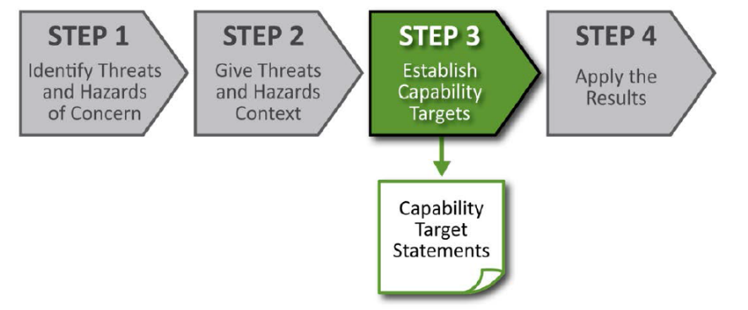

Impacts and Desired Outcomes

Capability targets should be specific and measurable. To develop specific and measurable targets, planners should consider impacts and desired outcomes for each threat and hazard.

Impacts

Impacts describe how a threat or hazard might affect a response capability. Impacts are linked to the size and complexity of threats and hazards. Larger, more complex threats and hazards might cause larger, more complex impacts.

. During response and recovery operations, impacts often describe actions that a community would take to manage an incident after it has occurred (e.g., rescue 500 people; provide food and shelter for 1,000 evacuees; provide long-term housing for 200 displaced families).
. During prevention, protection, and mitigation activities, impacts often describe actions a community would take prior to an incident to stop it from occurring or to reduce its effects (e.g., screen 80,000 event attendees for weapons; receive situation reports from four partner agencies).

Impacts should be specific and include quantitative descriptions as much as possible to allow jurisdictions to gain an understanding of what is needed to manage risk. Planners may seek to express impacts using the following types of categories:

. Size of geographic area affected
. Number of displaced households
. Number of fatalities
. Number of injuries or illnesses
. Disruption to critical infrastructure
. Intelligence requirements and needs
. Amount of direct economic impacts
. Economic effects of supply chain disruption.

Planners can use a range of inputs, including expert judgment and advanced modeling, to consider impacts. Given the breadth of preparedness mission areas and response capabilities, planners should work with the full range of partners to develop, review, and validate impacts.

Desired Outcomes

Desired outcomes describe the timeframe or level of effort needed to successfully deliver response capabilities. Capabilities are only useful if communities can deliver them in a timely and effective manner. For example, success in response and recovery missions often requires communities to deliver capabilities within a certain timeframe (e.g., complete search and rescue operations within 72 hours). Other missions may be better presented in terms of percentages (e.g., ensure 100% verification of identity to authorize, grant, or deny physical and cyber access to specific locations).

When considering desired outcomes, planners should not be constrained by current ability to meet timeframes or other conditions of success. Planners should consider various types of time-based desired outcomes.

Outcome Types | Example Outcome Descriptions
Completing operations | Complete evacuation of neighborhood within four hours
Establishing services | Establish feeding and sheltering operations for displaced populations within 24 hours
Service duration | Maintain behavioral screening checks for affected population for one month
Combination | Establish feeding and sheltering operations within 24 hours and maintain services for a period of two weeks

Developing Capability Targets

Capability targets define success and describe what the community wants to achieve for each response capability. Planners should combine quantitative details from impacts and desired outcomes to develop capability targets.

Straightforward Example

For some capabilities, forming the capability target may be as simple as combining the largest impacts with corresponding desired outcomes. As an example, consider a community developing a capability target for a fatality management services capability.

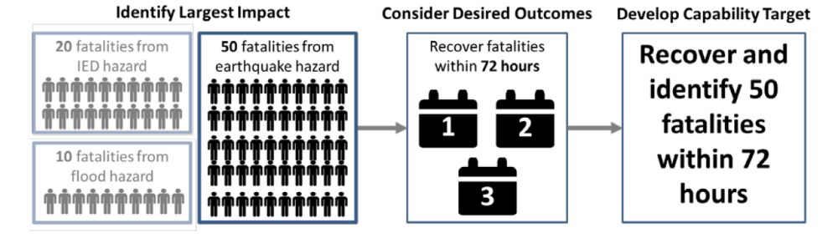

Complex Example

For some capabilities, developing capability targets may be more complicated. Different threats and hazards may stress different facets of a capability. As an example, consider a community developing capability targets for a critical transportation capability:

. The community reviews its ability to conduct critical transportation with potential impacts and desired outcomes:
• A fire threatens a chemical plant which could release toxic gases, thereby requiring the community to evacuate several city blocks in the direction that the toxic cloud is estimated to disperse. The affected area is over three square miles, and houses 20,000 residents who must be evacuated in three hours.
• An earthquake requires the delivery of vital response personnel, equipment, and services within 12 hours. 150 miles of major highway need to be assessed and repaired.

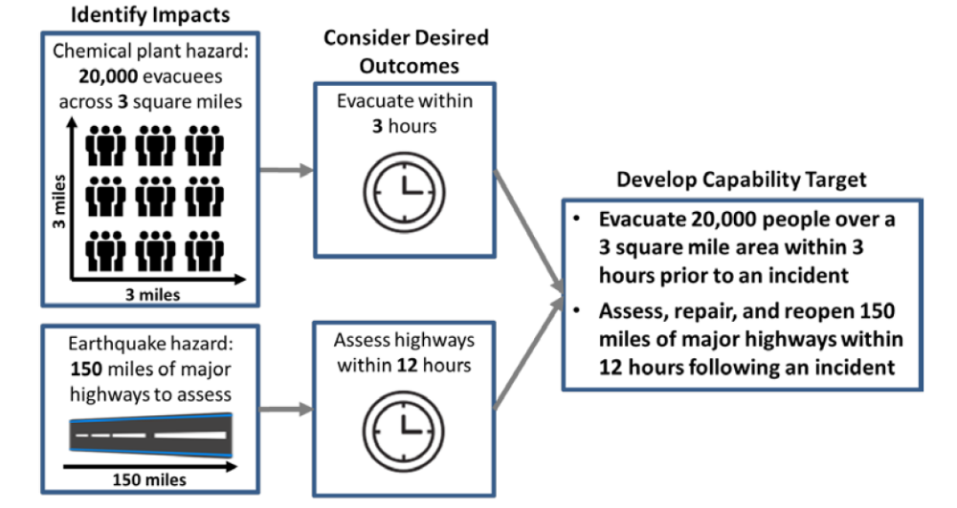

By developing capability targets that account for the range of impacts and desired outcomes associated with their different threats and hazards, planners will develop a “meta-scenario.”

A meta-scenario combines the context statements developed in Step 2 and includes the most stressing aspects of each threat and hazard. This approach leads to capability targets that increase at each level of government, specifically: a province needs to prepare for the worst impacts across multiple districts and a region needs to prepare for the worst impacts across multiple provinces.

Example Capability Target

Below is an example of a capability target for a mass search and rescue operations response capability for a community. The capability target includes the following impacts: the numbers of buildings to be searched, people to be rescued, and families to be sheltered. The target also describes the desired outcomes: completing collapse search and rescue within 72 hours. Communities should produce such a table for each capability.

Threat/Hazard | Earthquake | Terrorism
Context  Description | A magnitude 7.8 earthquake along the Mainland Fault occurring at approximately 2:00 PM on a weekday with ground shaking and damage expected in 19 districts, extending from Alpha District in the south to tau District in the North and into the Zeta Valley. | A potential threat exists from domestic group with a history of using small IEDs in furtherance of hate crimes. There are a number of large festivals planned during the summer at open air venues that focus on various ethnic and religious groups. These events draw on average 10,000 attendees daily.
Capability: Mass Search and Rescue Operations
Capability Target | Within 72 hours, rescue:  - 5,000 people in 1,000 completely collapsed buildings  - 10,000 people in 2,000 non-collapsed buildings  - 20,000 people in 5,000 buildings  - 1,000 people from collapsed light structures

Step 4: Apply the Results

In Step 4, communities apply the results of the THIRA by estimating the resources required to meet capability targets. Communities express resource requirements as a list of resources needed to successfully manage their threats and hazards. Planners can also use resource requirements to support resource allocation decisions, operations planning, and mitigation activities.

. Introduces capability estimation
. Discusses resources and other standardized resource types
. Provides an example of a completed resource requirement list
. Identifies how communities may apply these results to resource allocation decisions and mitigation activities.

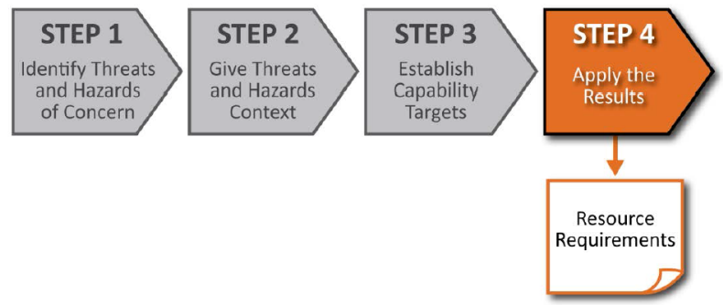

Capability Estimation

To estimate resource requirements, planners should consider the resources needed to achieve the capability targets from Step 3. As a first step, identify the major actions needed to achieve their capability targets. Planners should avoid developing very detailed, tactical-level task lists. Rather, strive to identify mission-critical activities. Planners can draw mission-critical activities from current community-level plans.

Planners should consider the quantity and types of resources needed to complete each mission-critical activity in support of the capability targets. To identify quantity and types of resources, communities can use existing tools and information sources, such as:

. Strategic, operational, and/or tactical plans
. Resource typing data, including standardized resource characteristics
. Existing capacity analysis and capability calculators
. Data regarding resources frequently requested through mutual aid.

Through this process, planners should identify the resources from across the entire community needed to meet capability targets.

Each community should decide which combination of resources is most appropriate to achieve its capability targets. While any number of combinations may achieve success, planners should consider costs, benefits the resources provide, and the ability to manage the risks associated with each potential solution. Different solutions may fit best within different communities’ political and economic frameworks.

Resources

Resources should be categorized: by capability, the resources requested, deployed, and used in incidents. Resource typing helps communities request and deploy needed resources through the use of common terminology. Communities should develop resource requirement lists to be included in all levels of response plans. Below is an example of the desired level of details when documenting resources:

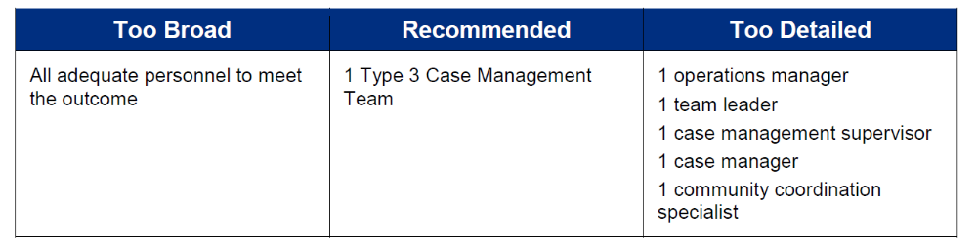

For some capabilities, planners can calculate resource requirements by considering: capability targets; the operational capacities of resources; and available time.

Resource Allocation Decisions

A community can use its THIRA results to make decisions about how to allocate limited resources. By establishing resource requirements, planners can determine the resources needed to achieve capability targets.

In some cases, THIRA results may indicate a need to sustain existing capabilities. In other cases, results may identify resource shortfalls and capability gaps. Planners can use this information to guide capability investment decisions and to brief community leaders, senior officials, and the public on resource requirements. Planners have several options available to build or sustain capabilities, including:

. In some cases, communities may rely upon the resources of other levels of government to achieve a capability target. Accordingly, districts, provinces, and regions should work collaboratively to build and sustain capabilities. For example, if a province requires federal resources to meet a capability target, they should collaborate with federal officials.
. Communities can build capabilities and fill gaps in a variety of other ways. For example, communities can:
• Establish mutual aid agreements with surrounding areas
• Work with community partners to augment capabilities
• Invest community or grant dollars
• Request technical assistance for planning or exercises to help deploy resources more effectively.

Regardless of how a community chooses to make resource allocation decisions, the THIRA process provides a framework to establish resource requirements and monitor progress towards building, sustaining, and delivering capabilities.

Preparedness Activities

THIRA results can also inform preparedness activities, including mitigation opportunities that may reduce the amount of resources required in the future. Through the THIRA process, planners can identify opportunities to employ mitigation plans, projects, and insurance to reduce the loss of life and damage to property. In this way, planners can reduce the impacts they need to manage, and hence reduce the resources needed to achieve capability targets.

Step 4 Output

In Step 4, planners develop a list of resource requirements to meet the capability targets while also considering preparedness activities that may reduce future resource requirements.

Conclusion

Achieving a preparedness goal requires participation by the entire community. Consistent application of THIRAs provides an important tool for integrating community contributions toward achieving a preparedness goal. Through the THIRA process, planners are better able to educate individuals, families, businesses, organizations, community leaders, and senior officials about the risks they face and their roles in and contributions to prevention, protection, mitigation, response, and recovery.

Appendix A: Glossary

Capability Target: Capability targets define success for each capability and describes what the community wants to achieve by combining detailed impacts with basic and measurable desired outcomes based on the threat and hazard context statements developed in Step 2 of the THIRA process.

Context: A community-specific description of an incident, including location, timing, and other important circumstances.

Desired Outcome: The standard to which incidents must be managed, including the timeframes for conducting operations or percentage-based standards for performing security activities.

Human-caused Hazard: A potential incident resulting from the intentional actions of an adversary.

Impact: How a threat or hazard might affect a core capability.

Likelihood: The chance of something happening, whether defined, measured, or estimated objectively or subjectively, or in terms of general descriptors (e.g., rare, unlikely, likely, almost certain), frequencies, or probabilities.

Natural Hazard: A potential incident resulting from acts of nature.

Resource Requirement: An estimate of the number of resources needed to achieve a community’s capability target. A list of resource requirements for each core capability is an output of the THIRA process.

Resource Typing: Categorizing a resource using common terminology for use in all levels of planning. A common example is combining multiple incident command personnel into a team, e.g. Incident Command Team.

Technological Hazard: A potential incident resulting from accidents or failures of systems or structures.

Threat/Hazard Effect: The overall impacts to the community were an incident to occur.

